

**DAEWOO PAKISTAN EXPRESS BUS SERVICE LTD.**

**231-Ferozepur Road, Lahore-Pakistan.**

**Tel: 92-42-35882918 UAN: 92-42-111-007-006 Fax: 92-42-35884021**

CAREER CERTIFICATE

**Date: <To2>**

It is certified that below mentioned person has served in our company during said period:

Name : <Name>

Duration : <From2> to <To2>

NIC NO : <CNIC>

Badge No : I.D - 12081

Job Trade : <Designation>

Upon his own request, this certificate was given to him.

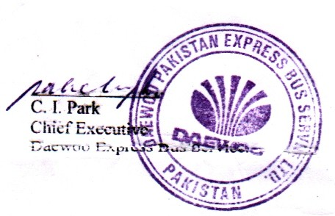

**General Manager Admin & HR**